1. **Physical Design**

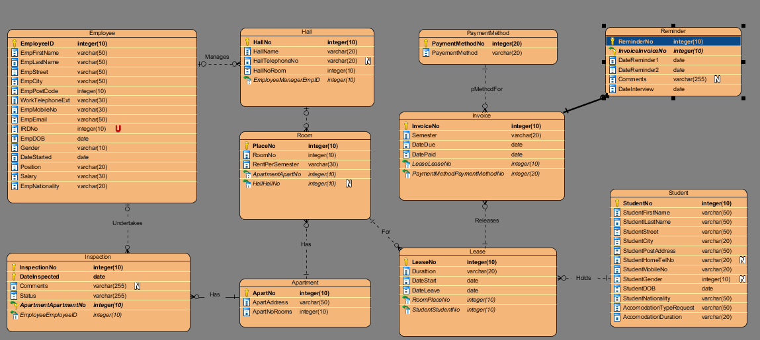

**DDL Script**

* 1. **Design Decisions / Assumption Made**
* Inspection

“InspectionNo” is added as the Primary Key, because the Inspection table has repeating information. It is there so that it has unique number to identify. This unique identifier will prevent any clash with the repeating inspection dates set by any employee.

* EmployeeID is being used instead of EmployeeNo
* EmpMobileNo
* HomeTelExt is being used instead of EmpMobileNo, because people nowadays have access to mobile phones instead of home phone.
* ReminderNo is used as a primary key in Reminder because it is easier to find the number and to ensure data in the specific column is unique.
* InspectionNo is used as a primary key in Inspection because it is easier to find the number and to ensure data in the specific column. This helps the user to find the inspection number through a unique number making it more accessible for the user.
  1. **Data Dictionary and Database Size**
     1. Employee

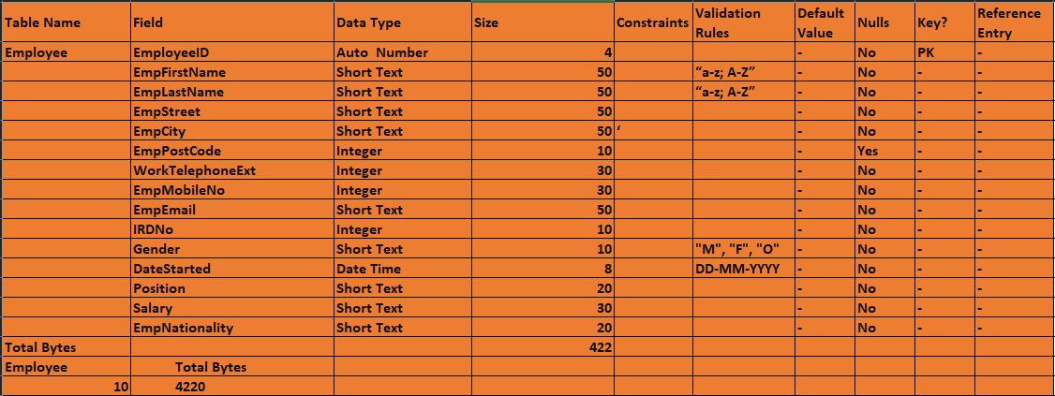

* + 1. Hall

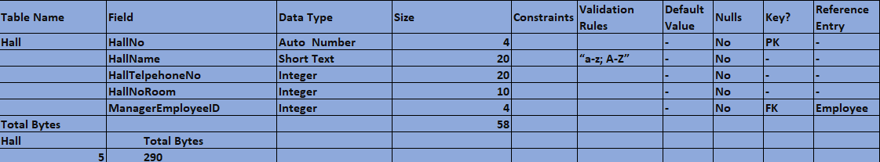

* + 1. Room

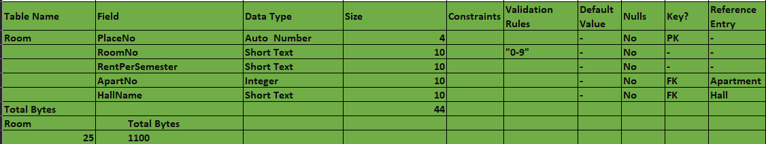

* + 1. Apartment

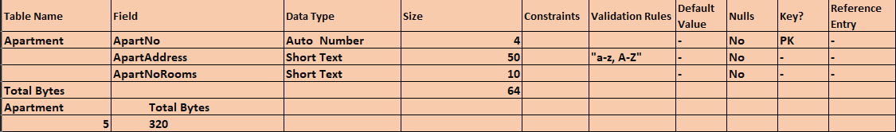

* + 1. Inspection

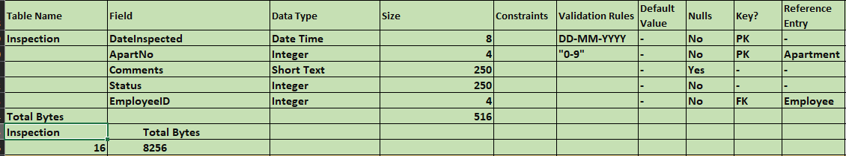

* + 1. Invoice

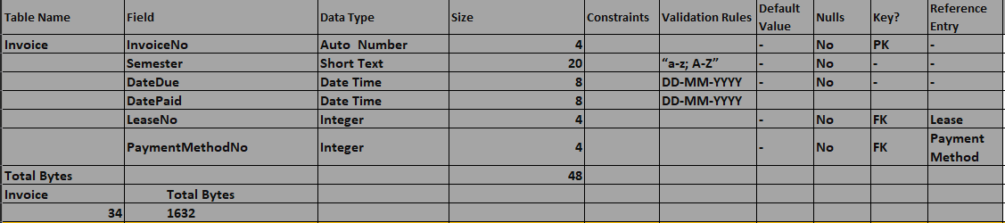

* + 1. Lease

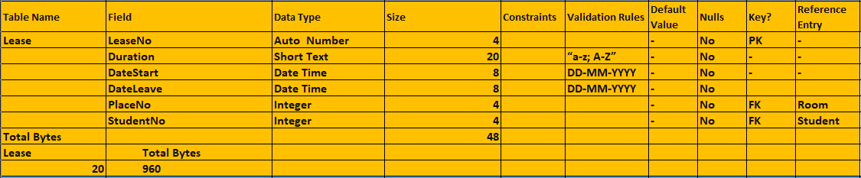

* + 1. Reminder

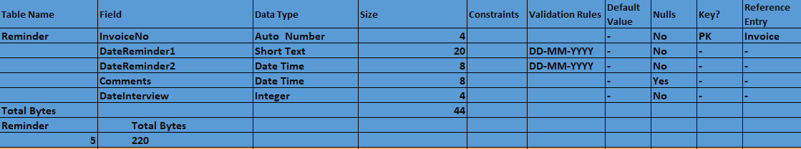

* + 1. Student

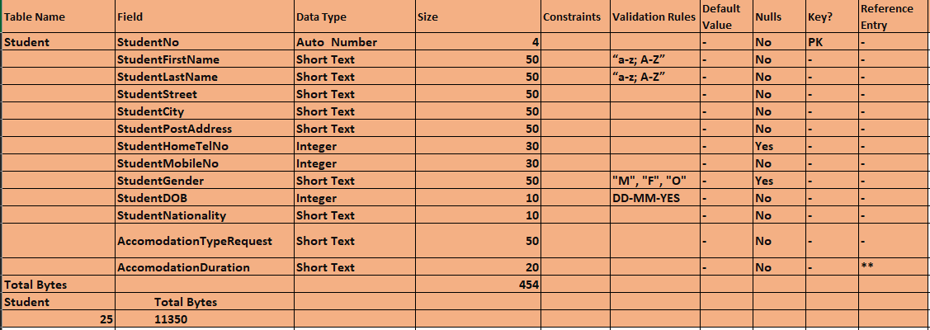

* + 1. Payment Method

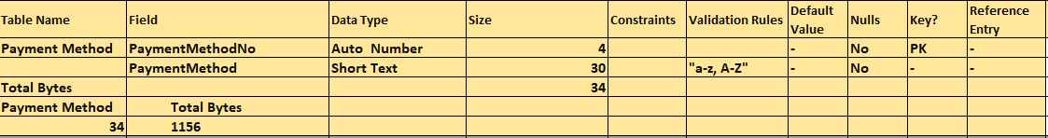

* + 1. Database Size

